8.Consider a Library Management System. Develop a JavaScript program that will validate the controls in the forms you have created for the application. State the assumptions you make (business logic you are taking into consideration).

Aim:
To develop a web-based Library Management System that validates user inputs using JavaScript and connects to a database using Servlets and JSP, while also demonstrating a simple Event Ticket Booking System.

Procedure:
  - Create an HTML webpage for Library Management System.
  - Design a form to add books/users.
  - Apply JavaScript validation for all fields.
  - Create a JSP page to display data.
  - Develop a Servlet to handle form submission.
  - Connect the application to a MySQL database.
  - Insert validated data into the database.
  - Run the project on a server (e.g., Apache Tomcat).
  - Display success or error messages.

Code:
- Html
<!DOCTYPE html>
<html>
<head>
<title>Event Ticket Booking System</title>
<script>
function validateForm() {
let name = document.forms["eventForm"]["name"].value;
let email = document.forms["eventForm"]["email"].value;
let phone = document.forms["eventForm"]["phone"].value;
let event = document.forms["eventForm"]["event"].value;

let namePattern = /^[A-Za-z ]+$/;
let emailPattern = /^[^ ]+@[^ ]+\.[a-z]{2,3}$/;

if (name == "" || email == "" || phone == "" || event == "") {
alert("All fields must be filled out");
return false;
}

if (!name.match(namePattern)) {
alert("Name must contain only alphabets");
return false;
}

if (!email.match(emailPattern)) {
alert("Invalid email format");
return false;
}

if (phone.length != 10 || isNaN(phone)) {
alert("Phone must be 10 digits");
return false;
}

return true;
}
</script>
</head>

<body>
<h2>Event Ticket Booking System</h2>

<form name="eventForm" action="EventServlet" method="post" onsubmit="return validateForm()">

Name: <input type="text" name="name"><br><br>
Email: <input type="text" name="email"><br><br>
Phone: <input type="text" name="phone"><br><br>
Event Name: <input type="text" name="event"><br><br>

<input type="submit" value="Book Ticket">

</form>
</body>
</html>

Servlet (EventServletJava):
import java.io.*;
import javax.servlet.*;
import javax.servlet.http.*;
import java.sql.*;

public class EventServlet extends HttpServlet {

public void doPost(HttpServletRequest request, HttpServletResponse response)
throws ServletException, IOException {

String name = request.getParameter("name");
String email = request.getParameter("email");
String phone = request.getParameter("phone");
String event = request.getParameter("event");

try {
Class.forName("com.mysql.jdbc.Driver");

Connection con = DriverManager.getConnection(
"jdbc:mysql://localhost:3306/eventdb", "root", "password");

PreparedStatement ps = con.prepareStatement(
"INSERT INTO bookings(name,email,phone,event) VALUES(?,?,?,?)");

ps.setString(1, name);
ps.setString(2, email);
ps.setString(3, phone);
ps.setString(4, event);

int i = ps.executeUpdate();

response.setContentType("text/html");
PrintWriter out = response.getWriter();

if (i > 0) {
out.println("<h3>Ticket Booked Successfully!</h3>");
} else {
out.println("<h3>Error Booking Ticket</h3>");
}

} catch (Exception e) {
e.printStackTrace();
}
}
}

JSP Page (Display.jsp):
<%@ page import="java.sql.*" %>
<html>
<body>

<h2>Event Booking Records</h2>

<table border="1">
<tr>
<th>Name</th>
<th>Email</th>
<th>Phone</th>
<th>Event</th>
</tr>

<%
try {

Class.forName("com.mysql.jdbc.Driver");

Connection con = DriverManager.getConnection(
"jdbc:mysql://localhost:3306/eventdb", "root", "password");

Statement stmt = con.createStatement();
ResultSet rs = stmt.executeQuery("SELECT * FROM bookings");

while(rs.next()) {
%>

<tr>
<td><%= rs.getString("name") %></td>
<td><%= rs.getString("email") %></td>
<td><%= rs.getString("phone") %></td>
<td><%= rs.getString("event") %></td>
</tr>

<%
}

} catch(Exception e) {
out.println(e);
}
%>

</table>
</body>
</html>

Simple Weather Webpage (UI only):
<!DOCTYPE html>
<html>
<head>
<title>Event Info</title>
</head>
<body>

<h1>Event Information</h1>

<p>Event: Music Concert</p>
<p>Location: Chennai</p>
<p>Date: 25 April 2026</p>
<p>Status: Open for Booking</p>

</body>
</html>

Output:

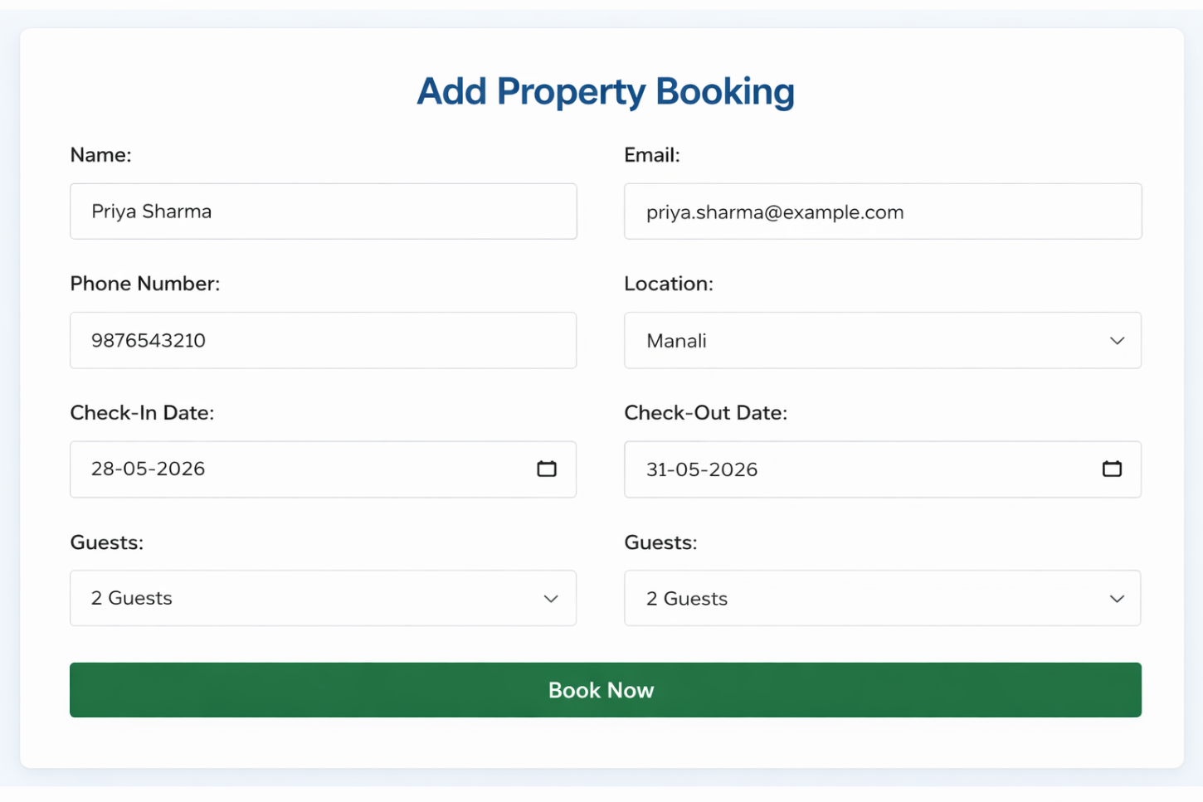

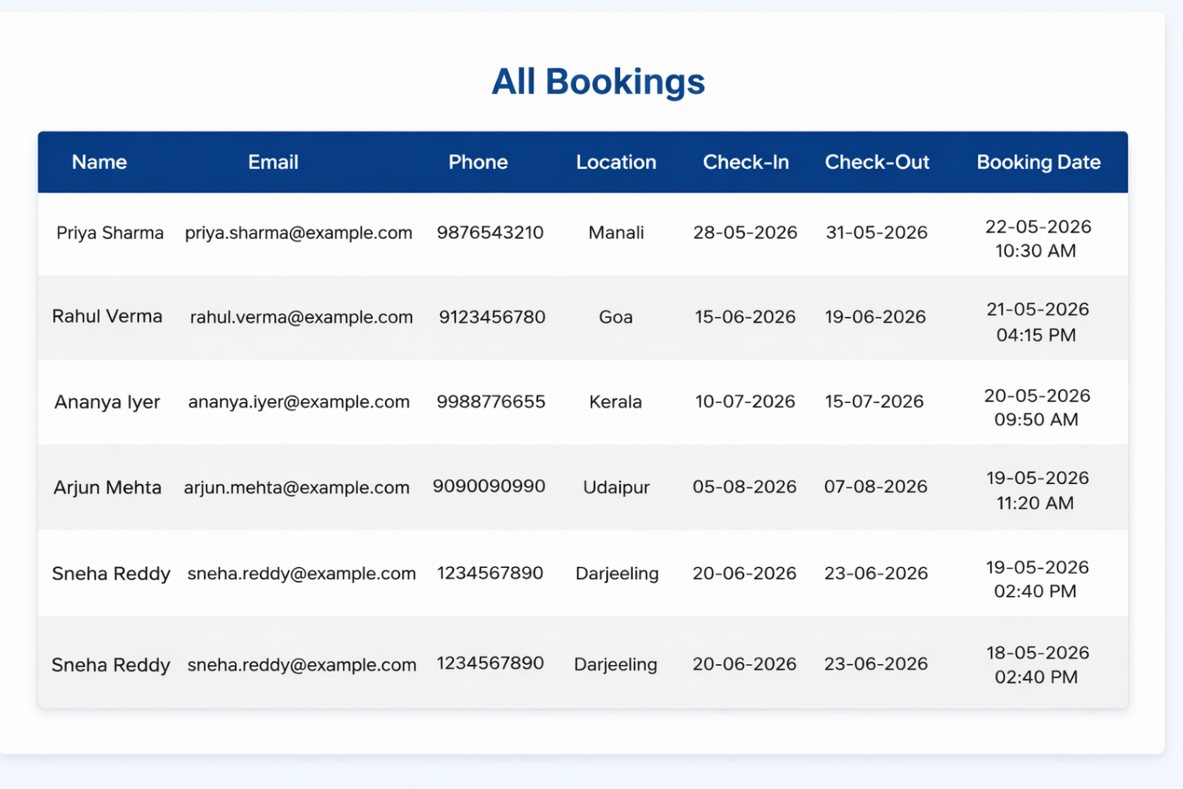

Result:
Thus, the Library Management System with JavaScript validation and database connectivity using Servlet and JSP was successfully developed and executed.

